GROUP PROJECT REPORT
CAMPUS FOOD DELIVERY AND ORDER MANAGEMENT SYSTEM
MODULE: PROGRAMMING FUNDAMENTALS | LEVEL 1.2 | 2026
GITHUB LINK
https://github.com/matovubryan45-design/campus-food-order-management-system.py.git

GROUP MEMBERS
No. | Member Name | Registration Number
1 | Kawalya Michael | VU-BIT-2603-0325-DAY
2 | Tembo Hannah | VU-BCD-2603-3281-day
3 | Tshomba Fundi | VU-BCS-2603-1706-DAY
4 | Kamwesigye Crissy | VU-BSF-2603-2730-DAY
5 | Paite Lawrence Angelo | VU-BCD-2603-1659-DAY
6 | Matovu Brian | VU-BBC-2603-1580-DAY]
7 | Nakyanzi Peace | VU-BCD-2603-0477-DAY
8 | Mwami Noven Blair | VU-BIT-2603-1876-DAY
9 | Ariniitwe Deus | VU-DIT-2603-2903-DAY

1. INTRODUCTION
As a group, we developed a Campus Food Delivery and Order Management System using Python. The project was given as part of our Programming Fundamentals coursework. The purpose was to build a small working system that can help a campus canteen take food orders digitally instead of depending on shouted orders and handwritten tickets. Our system allows a user to view the menu, take an order, calculate the cost, assign a rider, track delivery status, save orders and produce a sales report.

2. PROJECT OBJECTIVES
- Create a digital menu with meals, drinks and snacks.
- Allow several food items and quantities to be selected.
- Calculate the subtotal, delivery fee and final total.
- Assign completed orders to available riders.
- Track orders through Pending, Out for Delivery and Delivered stages.
- Save orders to a file and load them again when the program starts.
- Generate a sales report showing revenue, best-selling item and order status counts.
- Use input validation and functions to make the system simple to operate.

3. SYSTEM DESIGN AND MAIN FEATURES

3.1 Menu Setup
We created a menu dictionary with three categories: Meals, Drinks and Snacks. Each item has a menu number, name and price. This makes it possible to display the menu and find the correct price when a customer selects an item.

3.2 Taking an Order
The customer selects item numbers and enters quantities. The program checks that the item number is valid and that the quantity is a positive whole number. Selected items are kept in a cart until the customer enters 0 to finish.

3.3 Order Calculation
For each selected item, the system gets its name and price and calculates the line total using price multiplied by quantity. The line totals are added to get the subtotal. A delivery fee is then calculated and added to get the final total.

3.4 Rider Assignment and Status Tracking
After an order is confirmed, the user chooses a rider from a predefined list. The order starts as Pending and can move forward to Out for Delivery and then Delivered. This prevents an order from skipping stages.

3.5 File Persistence
We save order records in a JSON file. When the program starts, it loads existing orders. Error handling is included so a missing or damaged file does not cause the whole program to crash.

3.6 Sales Report and Saved Orders
The sales report calculates total revenue, identifies the best-selling item and counts orders by status. The saved orders section displays the order ID, total, status and rider.

3.7 Main Menu
The main function brings all features together in a looping menu. The user can display the menu, take an order, update status, view the sales report, show saved orders or exit.

4. SCREENSHOTS OF THE SYSTEM
Insert clear screenshots of the actual working program in the spaces below.
SCREENSHOT 1 – MAIN MENU
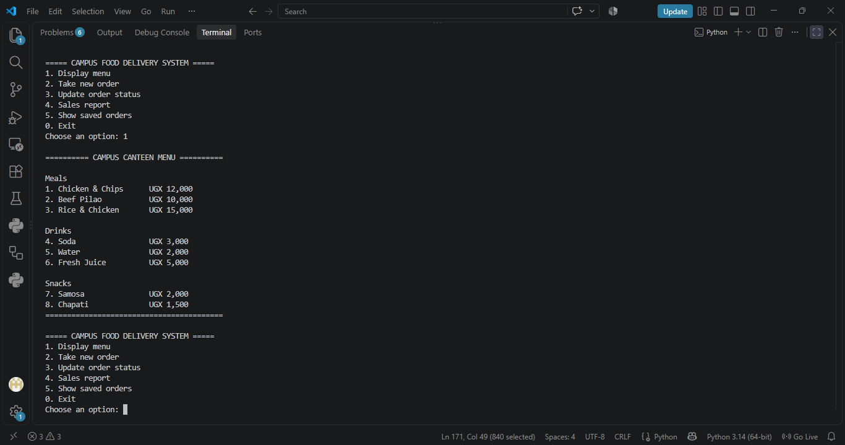

SCREENSHOT 2 – MENU AND TAKING AN ORDER
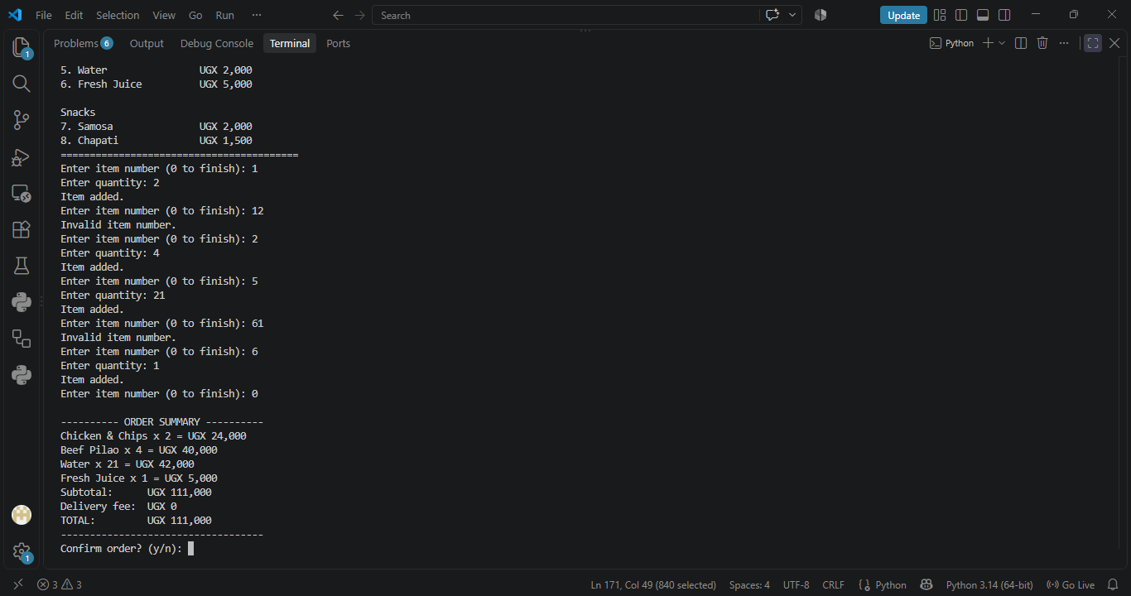

SCREENSHOT 3 – ORDER SUMMARY AND CALCULATION
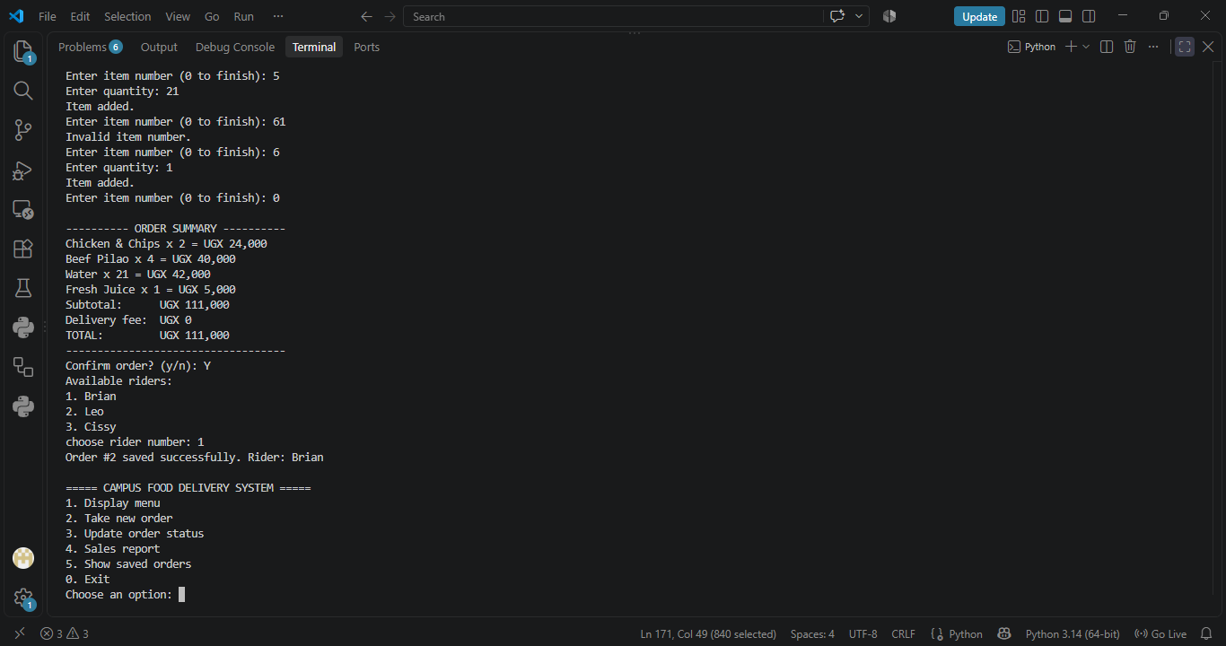

SCREENSHOT 4 – RIDER ASSIGNMENT / STATUS UPDATE
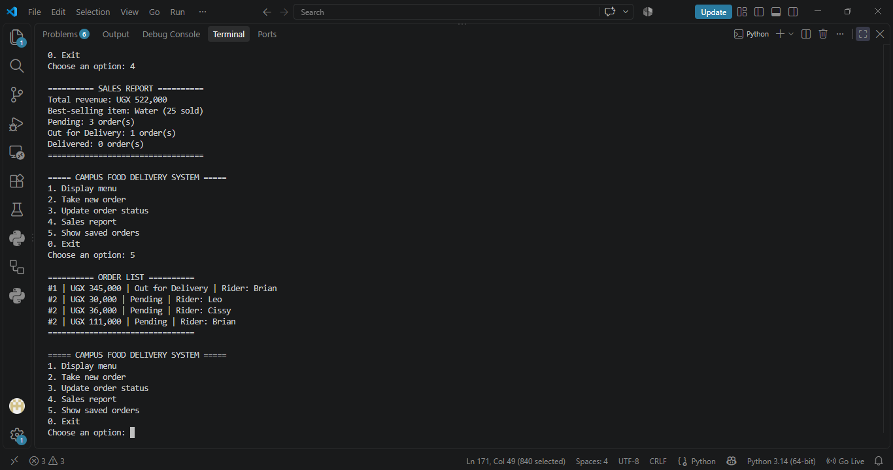

SCREENSHOT 5 – SALES REPORT / SAVED ORDERS
[INSERT SCREENSHOT HERE]

5. GROUP WORK DIVISION
As a group of eight members, we divided the project into smaller sections. Each member was mainly responsible for one area, but we worked together during integration and testing. The final names and registration numbers can be entered in the table below.
No. | Member | Main Responsibility
1 | Kamwesigye Crissy | Menu setup and data structures
2 | Paite Lawrence Angelo | Taking orders and input validation
3 | Ariniitwe Deus | Order calculation and delivery fee
4 | Kawalya Michael | Rider selection and status tracking
5 | Tshomba Fundi and Mwami Noven Blair | Loading and saving orders
6 | Nakyanzi Peace | Sales report and reporting
7 | Tembo Hannah | Main menu and system integration
8 | Matovu Brian | Testing, screenshots, documentation and final review

6. CHALLENGES AND HOW WE SOLVED THEM

Understanding Python
As beginners, concepts such as functions, dictionaries, lists, loops and JSON files were new to us. We solved this by studying each section separately, explaining the code to one another and testing small parts before combining them.

Input validation
Users can enter wrong menu numbers, quantities or order IDs. We added checks and clear messages so the user can try again instead of the program failing.

Saving and loading data
We needed orders to remain available after the program closes. We used a JSON file and added error handling for missing or unreadable files.

Combining group work
Different members developed different functions. We used meaningful function and variable names and tested the complete program together so the parts could work as one system.

7. TESTING AND RESULTS
As a group, we tested the main functions using different inputs. We checked that valid menu selections could be added, quantities were calculated correctly, delivery fees were applied, riders could be selected and order statuses could move through the correct stages. We also tested saving and loading so that orders could remain available between program runs. Invalid menu numbers, quantities and order IDs were tested to make sure the program displayed clear messages and allowed the user to try again. The sales report was also tested for revenue, best-selling item and status counts.

8. CONCLUSION
In conclusion, our group developed a basic Campus Food Delivery and Order Management System in Python. The project helped us understand how programming can be used to solve a real problem. We used functions, lists, dictionaries, loops, conditions, input validation, file handling and JSON storage in one complete program. Working as a group also helped us learn how to divide a problem into smaller parts and combine the parts into one working system. Although we faced challenges as beginners, we improved through practice, testing and explaining the code to one another.

